
Perfect Game SEC: Alabama | Georgia | North Carolina | South Carolina | Tennessee | Virginia

June 12, 2025

Subject: Perfect Game Southeast Coastal (SEC): A Leader in Amateur Baseball

Perfect Game Southeast (SEC) stands as a premier entity in the amateur baseball landscape, dedicated to providing unparalleled opportunities for young athletes to showcase their talents, develop their skills, and pursue their dreams of playing at the collegiate and professional levels.

Our Impact:

- Teams: We annually host and manage hundreds of highly competitive teams, ranging from youth divisions to high school showcases.
- States: Our extensive network and event schedule cover a broad geographical footprint, primarily spanning the entire southeastern United States and beyond.
- Participants: Each year, we welcome thousands of aspiring baseball players, giving them platforms to compete against top-tier talent and gain exposure to college coaches and professional scouts. Our events are meticulously organized, focusing on player development, competitive integrity, and a professional experience for all involved.

Proposed Event: Perfect Game International All-State Showcase - Bahamas Bound!
We are excited to propose a unique and high-impact event: the Perfect Game International All-State Showcase, culminating in a truly special experience in the Bahamas.

This event will operate as an "all-state" type opportunity, designed to attract individual players from across the country who demonstrate exceptional skill and potential. Unlike traditional team-based registrations, we will extend invitations to these standout individual athletes, forming composite "All-State" teams specifically for this international showcase.

Our vision is to bring these specially curated teams from the United States to the beautiful Bahamas, creating a dynamic international competition. A key aspect of this event is also to foster global participation and local engagement:

US All-State Teams: Players from various states will be selected to form elite teams representing the diverse talent pool of the United States.
Caribbean and Local Teams: We will actively invite and encourage fully rostered, established teams from Caribbean nations and local Bahamian communities to participate. This ensures a rich blend of playing styles and cultural exchange, offering a truly unique competitive environment for all athletes involved.
This format provides an unparalleled opportunity for individual players to gain exposure, compete internationally, and experience a world-class baseball event in an unforgettable setting. For participating established teams, it's a chance to test their mettle against top US talent and showcase their abilities on an international stage.

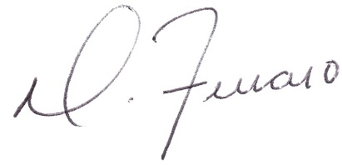

Dominick J. Ferraro
Perfect Game SEC, Managing Partner

Upstate, SC: pgupstate@perfectgame.org Charlotte, NC: pgcharlotte@perfectgame.org Triangle, NC: pgtriangle@perfectgame.org
Western, NC: pgwesternnc@perfectgame.org Triad, NC: pgtriad@perfectgame.org



