

Employee Contract
This Employee Contract (the "Agreement") is made and entered into as of January 8, 2025, by and between Perfect Game SEC, LLC, a Delaware corporation (the "Company"), and Cory Welch (the "Employee").
1. Employment Term: The Company hereby agrees to employ the Employee, and the Employee hereby agrees to work for the Company, as Coastal Area Director, effective January 1, 2025, through December 31, 2025.
2. Duties and Responsibilities: The Employee agrees to perform the duties and responsibilities assigned by the Company, which may include, but are not limited to:
The duties and responsibilities of a baseball area tournament director can vary depending on the specific organization and level of competition (e.g., showcase, high school, college, or professional). However, here are some common tasks and responsibilities associated with this role:
Tournament Planning and Organization:
- Facility Management: Securing and coordinating the use of tournament venues; including fields.
- Staffing Management: Recruiting, training, and managing directors for various tasks, such as site directing, gate workers, scorekeeping, field preparation, and concessions if applicable.
- Registration and Entry: Handling team registration, entry fees, and roster verification.
- Rule Enforcement: Ensuring that all tournament rules and regulations are followed by all participants.
- Phone Calls: Make personal phone calls to key contacts, such as team managers or coaches.
- Text Messages: Send concise text messages with registration links and deadlines.
- In-Person Interactions: If possible, attend local baseball events or tournaments to personally remind teams.
- Perfect Game SEC Support: The Company agrees to provide Employee with adequate staff, technology, and other resources necessary to effectively execute events on behalf of the Company.
3. Compensation: The Employee shall receive an annual base salary of $110,000, payable in thirteen (13) bi-weekly installments of approximately $8,461.53 each, commencing on May 19, 2025, and concluding in November of 2025. The Company may also provide additional compensation, such as bonuses, commissions, or benefits, as determined by the Company in its sole discretion.
4. Compensation Confidentiality Clause: Employee agrees to keep confidential the terms and conditions of their employment, including but not limited to, salary, bonuses, and other forms of compensation. Employee shall not disclose such information internally or to any third party without the prior written consent of the Company.
5. Field Ownership and Usage: Perfect Game SEC shall retain ownership and control of all fields that are currently titled in the Perfect Game SEC, LLC name. Perfect Game SEC, LLC shall maintain exclusive use of these fields for the duration of this Agreement. In the event of early termination of this Agreement by The Company, or Employee, Field Ownership and Usage will become null and void.
6. Good Standing and Commitment: The Company and Employee agrees to remain in good standing for the full initial term of this contract. The Company and Employee may not terminate their participation in the contract prior to the end of the initial term, except in the following circumstances:
- Mutual Agreement: Upon the mutual written consent of both parties.
- Material Breach: In the event of a material breach of this Agreement by either side is not cured within thirty days of written notice.
- Force Majeure: In the event of a Force Majeure event that prevents a from fulfilling their obligations under this Agreement.
- Misappropriation: The Company and Employee agree to protect confidential information and property. The Employee and Company shall not, directly or indirectly, misappropriate, steal, or otherwise wrongfully take any such confidential information or property. In the event of any such theft or misappropriation, the responsible party shall be liable for all damages, including but not limited to, direct, indirect, incidental, and consequential damages.

7. Confidentiality and Non-Solicitation: The Employee agrees to keep confidential all confidential information of the Company, including, but not limited to, trade secrets, customer lists, and business plans. The Employee also agrees not to solicit or hire any employee of the Company during or after the term of employment.
8. Non-Compete: During the term of employment, the Employee agrees not to:
- Engage in any business or occupation that is directly competitive with the Company's business within a 300-mile radius of the Company's principal place of business.
- Solicit or divert any customer or client of the Company.
- Hire or solicit any employee of the Company.

9. Intellectual Property: The Employee agrees that all intellectual property rights, including, but not limited to, inventions, copyrights, and trademarks, developed by the Employee during the course of employment shall be the sole property of the Company.
10. Entire Agreement: This Agreement constitutes the entire agreement between the parties and supersedes all prior or contemporaneous communications, representations, or agreements, whether oral or written.
11. Governing Law: This Agreement shall be governed by and construed in accordance with the laws of the State of South Carolina.
IN WITNESS WHEREOF, the parties have executed this Agreement as of the day and year first above written
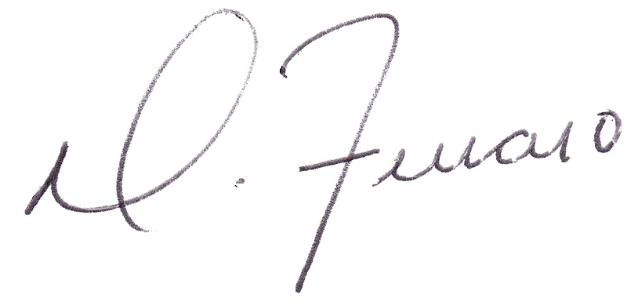

_________________________________
Dominick J. Ferraro
PG SEC, Managing Partner
_________________________________
Cory Welch
PG SEC, North & South Carolina State Director

