
Perfect Game SEC: Alabama | Georgia | North Carolina | South Carolina | Tennessee | Virginia

January 8, 2025

Subject: Contract Proposal & Compensation Package

Position: High School State Director (North & South Carolina)

Proposed Compensation: To retain teams for tournaments for 14u to 18u, we propose a competitive compensation package that includes the following:

- Base Salary: The Employee shall receive an annual base salary of $110,000, payable in thirteen (13) weekly installments of approximately $8,461.53 each, commencing on May 19, 2025, and concluding in November.
Key Performance Indicators (KPIs): To ensure fair and accurate measurement of performance and bonus eligibility, we propose the following KPIs:

- Participant Satisfaction: This KPI measures how satisfied participants, including players, coaches, and parents, are with the tournament experience. It can be measured through surveys, feedback forms, or online reviews.
- Financial Performance: This KPI tracks the financial success of the tournament. It includes metrics like total revenue, total expenses, and net profit. It also measures the efficiency of budget management and revenue generation.
- Tournament & Team Completion Rate: This KPI measures the percentage of scheduled games that are completed. It reflects the director's ability to manage logistics, weather conditions, and other unforeseen challenges to ensure the smooth running of the tournament.

Director Protection Clause: The employee's salary is contingent upon the successful achievement of the Key Performance Indicators (KPIs) as outlined in their official contract agreement.

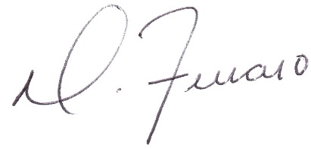

Dominick J. Ferraro
Perfect Game SEC, Managing Partner

Upstate, SC: pgupstate@perfectgame.org Charlotte, NC: pgcharlotte@perfectgame.org Triangle, NC: pgtriangle@perfectgame.org
Western, NC: pgwesternnc@perfectgame.org Triad, NC: pgtriad@perfectgame.org



