

Mutual Termination Agreement
This Mutual Termination Agreement ("Agreement") is made and entered into as of February 28, 2025, by and between Perfect Game SEC a Delaware LLC with its principal place of business at 2607 Woodruff Road, Suite E227, Simpsonville, South Carolina 29681 ("PGSEC"), and TYPHI, a South Carolina LLC with its principal place of business at 1668 Woodlake Drive, Columbia, South Carolina 29206 ("TYPHI").
WHEREAS, PSEC and TYPHI entered into a certain agreement dated January 8, 2025, entitled Employee Contract (the "Original Agreement"); and
WHEREAS, PSEC and TYPHI mutually desire to terminate the Original Agreement in its entirety;
NOW, THEREFORE, in consideration of the mutual covenants and agreements contained herein, the parties agree as follows:
1. Termination of Original Agreement.
PSEC and TYPHI hereby agree to terminate the Original Agreement (as in Exhibit 1), effective as of February 28, 2025 (the "Termination Date"). As of the Termination Date, the Original Agreement shall be null and void, and neither party shall have any further obligations or liabilities thereunder, except as expressly provided in this Agreement.
2. Release of Claims.
Each party hereby releases and forever discharges the other party, its officers, directors, employees, agents, and successors, from any and all claims, demands, actions, causes of action, liabilities, damages, costs, and expenses, whether known or unknown, arising out of or relating to the Original Agreement, or the termination thereof.
3. No Further Obligations.
Except as expressly provided in this Agreement, neither party shall have any further obligations or liabilities to the other PSEC rising out of or relating to the Original Agreement.
4. Confidentiality.
The terms of this Agreement shall remain confidential and shall not be disclosed to any third party without the prior written consent of both parties, except as required by law.
5. Governing Law.
This Agreement shall be governed by and construed in accordance with the laws of the State of South Carolina.

6. Entire Agreement.
This Agreement constitutes the entire agreement between the parties with respect to the subject matter hereof and supersedes all prior or contemporaneous communications and proposals, whether oral or written.
7. Counterparts.
This Agreement may be executed in counterparts, each of which shall be deemed an original, but all of which together shall constitute one and the same instrument.

IN WITNESS WHEREOF, the parties have executed this Mutual Termination Agreement as of the date first above written.

Hunter Ives
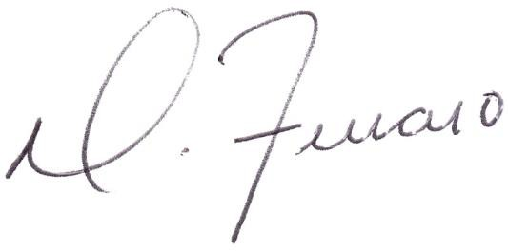
PG SEC (TYPHI), Director & UIC

Dominick J. Ferraro
PG SEC, Managing Partner

Exhibit 1
