
December 23, 2024
Perfect Game SEC: Alabama | Georgia | North Carolina | South Carolina | Tennessee | Virginia

Subject: Proposal | 2025 Joint Venture

Proposal: To ensure the continued success of the following tournament weekends for Hunter Ives (7U-18U) under the Perfect Game brand, we are proposing a competitive compensation package.

Rationale: Competing with well-established sanctioning bodies like Perfect Game presents significant challenges. Perfect Game has a long-standing reputation and a massive customer base. Their ability to attract players of all skill levels, including those highly coveted by college scouts, creates a competitive advantage that smaller organizations find difficult to overcome.

We propose relinquishing your four dates in North Augusta (March 15-16, May 10-11, September 14-15, November 1-2) in exchange for acquiring four weekend dates in Conway. The specific Conway dates will be determined at a later time.

- NET Revenue Split (80/20): Under this partnership agreement, 80% of the total net revenue generated from the tournament dates below will be allocated to Hunter Ives, with the remaining 20% going to Perfect Game.

  - Orangeburg (April 12-13, May 17-18, Oct 18-19)
  - Rocky Mount (March 22-23 & Sept 6-7)
  - Georgetown (Aug 23-24, Oct 11-12, Oct 25-26)
  - Hartsville (Sept 20-21, Oct 4-5)

Justification of the 20% Net Revenue Split: Perfect Game provides significant value for extensive marketing & promotion which leverages its strong brand and marketing resources, a robust Infrastructure that is well-established, including experienced staff, strong venue relationships, and a robust online platform, which significantly offers a distinct value proposition that differentiates it from competitors. With a focus on customer & director support services, Perfect Game also prioritizes building a strong reputation, attracting repeat business, and effectively supporting the needs of field directors.

- Umpire in Charge: Oversee the management & coordination of umpires in South Carolina at the High School level.

- Perfect Game Tournament Shirts: Hunter Ives will retain 100% of the profits from all tournament shirts sublimated by Hunter Ives for the following dates indicated above.

Director Protection Clause: All fields currently titled in Hunter Ives name will remain titled for the duration of this specific agreement.

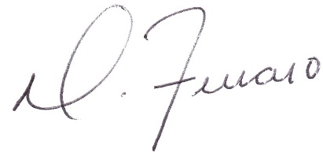

Dominick J. Ferraro
Perfect Game SEC, Managing Partner

Upstate, SC: pgupstate@perfectgame.org Charlotte, NC: pgcharlotte@perfectgame.org Triangle, NC: pgtriangle@perfectgame.org
Western, NC: pgwesternnc@perfectgame.org Triad, NC: pgtriad@perfectgame.org

