

Employee Contract
This Employee Contract (the "Agreement") is made and entered into as of March 5, 2025, by and between Perfect Game SEC, LLC, a Delaware corporation (the "Company"), and Michael Anderson (the "Employee").
1. Employment Term: This Employment Agreement will begin on April 7, 2025 ("Start Date"). The Company agrees to employ the Employee as an Area Director for North Carolina, with responsibilities in Greenville, Goldsboro, Rocky Mount, Snow Hill, Wilson, and other areas within the Down East Region of North Carolina.
The initial term of this Agreement shall be five (5) years, commencing on the Start Date, and is contingent upon the Area Director's successful retention of all currently utilized tournament facilities in Greene County, North Carolina. Upon completion of the initial term, this Agreement will automatically renew for subsequent three (3) year terms, unless either party provides written notice of intent not to renew at least sixty (60) days prior to the expiration of the then-current term.
2. Duties and Responsibilities: The Employee agrees to retain teams and host 7u-14u tournaments as a core responsibility within the duties and responsibilities outlined below.
Tournament Planning and Organization:

- Scheduling: Assistance in managing tournament schedules (times, locations, fields).
- Facility Management: Assistance in securing and coordinating tournament venues.
- Budgeting: Assistance in tournament budget oversight.
- Staffing Management: Assistance in staff recruitment, training, and management.
- Marketing and Promotion: Promote tournaments by using provided materials and media from PG SEC.
- Registration and Entry: Manage roster verification procedures.
- Rule Enforcement: Ensuring that all tournament rules and regulations are followed by all participants.

Tournament Operations:

- Umpire Assignment: Coordinate umpire assignments with the UIC.
- Game Management: Oversee game operations, including dispute resolution.
- Scorekeeping and Statistics: Ensure accuracy of game scorekeeping and statistics.
- Tournament Brackets: Assist in managing tournament brackets and seedling.
- Post-Game Procedures: If applicable, assist in managing post-game tasks and dispute handling.
- Emergency Preparedness: Ensure tournament emergency preparedness (medical, weather).
- Communication: Manage communication with teams, coaches, officials, volunteers, and fans.

3. Compensation: The Area Director, as a W-2 employee, will receive a competitive compensation package from PG SEC, featuring an $86,000 annual salary paid in 26 bi-weekly installments of approximately $3,307.69, along with health benefits subject to company policies and standard tax withholding.
The Company retains the sole discretion to provide supplementary compensation, including, but not limited to, bonuses, commissions, or other benefits.
4. Compensation Confidentiality Clause: Employee agrees to keep confidential the terms and conditions of their employment, including but not limited to, salary, bonuses, and other forms of compensation. Employee shall not disclose such information internally or to any third party without the prior written consent of the Company.
5. Good Standing and Commitment: The Company and Employee agrees to remain in good standing for the full term of this contract. The Company and Employee may not terminate their participation in the contract prior to the end of the initial term, except in the following circumstances:
- Mutual Agreement: Upon the mutual written consent of both parties.
- Material Breach: In the event of a material breach of this Agreement by either side is not cured within thirty days of written notice.
- Force Majeure: In the event of a Force Majeure event that prevents a from fulfilling their obligations under this Agreement.
- Misappropriation: The Company and Employee agree to protect confidential information and property. The Employee and Company shall not, directly or indirectly, misappropriate, steal, or otherwise wrongfully take any such confidential information or property. In the event of any such theft or misappropriation, the responsible party shall be liable for all damages, including but not limited to, direct, indirect, incidental, and consequential damages.

6. Confidentiality and Non-Solicitation: The Employee agrees to keep confidential all confidential information of the Company, including, but not limited to, trade secrets, customer lists, and business plans. The Employee also agrees not to solicit or hire any employee of the Company during or after the term of employment.
7. Non-Compete: During the term of employment, the Employee agrees not to:
- Engage in any business or occupation that is directly competitive with the Company's business within a 300-mile radius of the Company's principal place of business.
- Solicit or divert any customer or client of the Company.
- Hire or solicit any employee of the Company.

8. Intellectual Property: The Employee agrees that all intellectual property rights, including, but not limited to, inventions, copyrights, and trademarks, developed by the Employee during the course of employment shall be the sole property of the Company.
9. Entire Agreement: This Agreement constitutes the entire agreement between the parties and supersedes all prior or contemporaneous communications, representations, or agreements, whether oral or written.
10. Governing Law: This Agreement shall be governed by and construed in accordance with the laws of the State of South Carolina.
IN WITNESS WHEREOF, the parties have executed this Agreement as of the day and year first above written
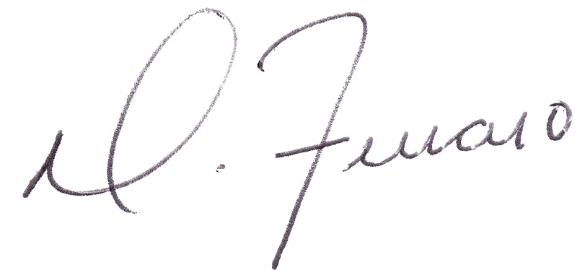

_________________________________
Dominick J. Ferraro
Perfect Game SEC, Managing Partner
_________________________________
Mike Anderson
Perfect Game, Area Director

