
March 1, 2025
Perfect Game SEC: Alabama | Georgia | North Carolina | South Carolina | Tennessee | Virginia

Subject: Contract Proposal, Compensation Package & Job Description

Position: Area Director, Perfect Game SEC (Down East Market)

Proposed Compensation Package: To retain teams and host 7u-14u tournaments in the Down East Market of North Carolina, PG SEC proposes a competitive compensation package. Starting March 15, 2025, the Area Director can choose from employment options that include an $86,000 annual salary, paid bi-weekly in 26 installments of approximately $3,307.69. This agreement guarantees at minimum a five (5) year term and beyond, contingent upon the Area Director's successful retention of all currently utilized tournament facilities in Greene County, North Carolina.
- W-2 Employment: Base salary of $86,000, health benefits subject to Company policies, and tax withholding.
- 1099 Contractor: Base salary of $86,000 responsible for taxes, insurance, and own resources. No benefits. Independent control of work within the contract terms.
Employment Responsibilities:

Tournament Planning and Organization:
- Scheduling: Assistance in managing tournament schedules (times, locations, fields).
- Facility Management: Assistance in securing and coordinating tournament venues.
- Budgeting: Assistance in tournament budget oversight.
- Staffing Management: Assistance in staff recruitment, training, and management.
- Marketing and Promotion: Promote tournaments by using provided materials and media from Perfect Game SEC.
- Registration and Entry: Manage roster verification procedures.
- Rule Enforcement: Ensuring that all tournament rules and regulations are followed by all participants.

Tournament Operations:
- Umpire Assignment: Coordinate umpire assignments with the UIC.
- Game Management: Oversee game operations, including dispute resolution.
- Scorekeeping and Statistics: Ensure accuracy of game scorekeeping and statistics.
- Tournament Brackets: Assist in managing tournament brackets and seedling.
- Post-Game Procedures: If applicable, assist in managing post-game tasks and dispute handling.
- Emergency Preparedness: Ensure tournament emergency preparedness (medical, weather).
- Communication: Manage communication with teams, coaches, officials, volunteers, and fans.

Director Protection Clause: Perfect Game SEC will indemnify the Director for legal expenses from good-faith service.

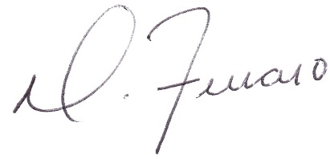
Dominick J. Ferraro
Perfect Game SEC, Managing Partner

Upstate, SC: pgupstate@perfectgame.org Charlotte, NC: pgcharlotte@perfectgame.org Triangle, NC: pgtriangle@perfectgame.org
Western, NC: pgwesternnc@perfectgame.org Triad, NC: pgtriad@perfectgame.org



