

Non-Solicitation Agreement of Umpires
This Agreement ("Agreement") is made and entered into as of February 27, 2025, by and between Perfect Game SEC, LLC, a Delaware Limited Liability Company with its principal place of business at 2607 Woodruff Road, Suite E227, Simpsonville SC 29681 ("PG SEC"), and North Carolina Umpires Association a North Carolina Non-Profit with its principal place of business at 115 Tidewater Drive, Newport North Carolina 29570 ("NCUA").
WHEREAS, PG SEC engages the services of NCUA for the purpose of obtaining qualified umpires to officiate its sporting events; and
WHEREAS, PG SEC and NCUA recognize the importance of maintaining a stable and reliable pool of umpires; and;
WHEREAS, PG SEC and NCUA mutually desire to enter into an agreement to establish a non-solicitation and non-recruitment understanding regarding umpires who are assigned to PG SEC events by NCUA.
NOW, THEREFORE, in consideration of the mutual covenants and agreements contained herein, the parties agree as follows:
1. Non-Solicitation.
- During the term of this Agreement, PG SEC shall not, directly or indirectly, solicit, recruit, or attempt to induce any umpire currently assigned by NCUA to officiate PG SEC events.
- This non-solicitation provision applies to all umpires who have been assigned by NCUA to exclusively officiate PG SEC events.
- "Solicit" and "Recruit" include, but are not limited to, making offers of employment, engaging in discussions regarding potential employment, and providing information about officiating opportunities.
2. Term and Termination.
- This Agreement shall become effective on the date first above written and shall remain in full force and effect until terminated in accordance with the provisions of this Agreement.
- Either party may terminate this Agreement upon a sixty (60) day written notice to the other party.
3. Confidentiality.
- Both parties agree to maintain the confidentiality of the terms of this Agreement.
4. Remedies.
- The parties acknowledge that a breach of this Agreement may cause irreparable harm for which monetary damages may be inadequate. Therefore, in the event of a breach or threatened breach of this Agreement, the non-breaching party shall be entitled to seek injunctive relief, in addition to any other remedies available at law or in equity.
- The prevailing party in any legal action arising out of or relating to this Agreement shall be entitled to recover its reasonable attorneys' fees and costs.

5. Governing Law.
- This Agreement shall be governed by and construed in accordance with the laws of the State of South Carolina.
6. Entire Agreement.
- This Agreement constitutes the entire agreement between the parties with respect to the subject matter hereof and supersedes all prior or contemporaneous communications and proposals, whether oral or written.
7. Amendments.
- This Agreement may be amended only by a written instrument signed and agreed upon by both parties.
8. Severability.
- If any provision of this Agreement is held to be invalid or unenforceable, the remaining provisions shall continue in full force and effect.

IN WITNESS WHEREOF, the parties have executed this Agreement as of the date first above written.

_________________________________
Robert Smith
North Carolina Umpire Association, Umpire in Charge (Triangle/Down East)
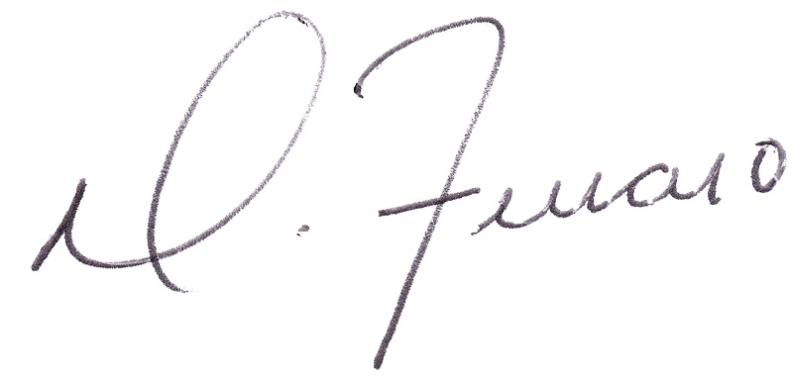
_________________________________
Dominick J. Ferraro
Perfect Game SEC, Managing Partner

