

Non-Solicitation Agreement of Umpires
This Agreement ("Agreement") is made and entered into as of [DATE], by and between [PARTY A NAME], a [STATE] [ENTITY TYPE] with its principal place of business at [ADDRESS] ("Party A"), and [PARTY B NAME], a [STATE] [ENTITY TYPE] with its principal place of business at [ADDRESS] ("Party B").
WHEREAS, Party A and Party B are engaged in [BRIEF DESCRIPTION OF RELATED ACTIVITIES, e.g., organizing and conducting sports leagues, tournaments, or events]; and
WHEREAS, both Party A and Party B utilize the services of umpires to officiate their respective events; and
WHEREAS, Party A and Party B recognize the importance of maintaining a stable and reliable pool of umpires; and
WHEREAS, Party A and Party B desire to enter into an agreement to prevent the solicitation and recruitment of umpires who are currently engaged by the other party.
NOW, THEREFORE, in consideration of the mutual covenants and agreements contained herein, the parties agree as follows:
1. Non-Solicitation.
- During the term of this Agreement, and for a period of [NUMBER] [MONTHS/YEARS] following its termination, neither party shall, directly or indirectly, solicit, recruit, or attempt to induce any umpire who is currently under contract or regularly officiating events for the other party to terminate their relationship with that party and provide officiating services to the soliciting party.
- This non-solicitation provision applies to all umpires who have performed services for the other party within the [NUMBER] [MONTHS/YEARS] immediately preceding the date of solicitation.
- "Solicit" and "Recruit" include, but are not limited to, making offers of employment, engaging in discussions regarding potential employment, and providing information about officiating opportunities.
- General advertising or public announcements of officiating opportunities that are not specifically targeted at the other party's umpires shall not be considered a violation of this Agreement.
2. Term and Termination.
- This Agreement shall commence on the date first above written and shall continue for a period of [NUMBER] [MONTHS/YEARS], unless earlier terminated as provided herein.
- Either party may terminate this Agreement upon [NUMBER] [DAYS/WEEKS/MONTHS] written notice to the other party.
- This agreement can be terminated immediately by either party if the other party breaches this agreement.
3. Confidentiality.
- Both parties agree to maintain the confidentiality of the terms of this Agreement.
4. Remedies.
- The parties acknowledge that a breach of this Agreement may cause irreparable harm for which monetary damages may be inadequate. Therefore, in the event of a breach or threatened breach of this Agreement, the non-breaching party shall be entitled to seek injunctive relief, in addition to any other remedies available at law or in equity.
- The prevailing party in any legal action arising out of or relating to this Agreement shall be entitled to recover its reasonable attorneys' fees and costs.
5. Governing Law.
- This Agreement shall be governed by and construed in accordance with the laws of the State of [STATE].
6. Entire Agreement.
- This Agreement constitutes the entire agreement between the parties with respect to the subject matter hereof and supersedes all prior or contemporaneous communications and proposals, whether oral or written.
7. Amendments.
- This Agreement may be amended only by a written instrument signed by both parties.
8. Severability.
- If any provision of this Agreement is held to be invalid or unenforceable, the remaining provisions shall continue in full force and effect.
IN WITNESS WHEREOF, the parties have executed this Agreement as of the date first above written.
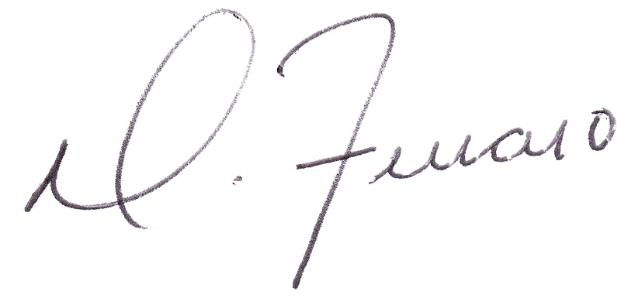
_________________________________
Robert Smith
Perfect Game SEC, Area Director (Triangle)
_________________________________

Dominick J. Ferraro
Perfect Game SEC, Managing Partner

