

Non-Disclosure Agreement (NDA)

This Non-Disclosure Agreement (“Agreement”) is entered into as of April 25, 2025, by and between Perfect Game SEC, LLC with its principal place of business at 2607 Woodruff Road, Suite E227, Simpsonville, SC 29681 (“Disclosing Party”), and Wesley Jones with its principal place of business at 1211 Plant Side Drives, Louisville, Kentucky 40299 (“Receiving Party”).

1. Definition of Confidential Information.

For purposes of this Agreement, “Confidential Information” means any and all information disclosed by Disclosing Party to Receiving Party, whether orally, in writing, electronically, or by any other means, that relates to Disclosing Party’s business, including, but not limited to:

- Technical information, including designs, drawings, specifications, formulas, and processes.
- Business information, including customer lists, pricing, marketing plans, and financial data.
- Proprietary information, including trade secrets, know-how, and unpublished patent applications.
- Any information designated as confidential by Disclosing Party.

2. Non-Disclosure and Non-Use.

Receiving Party agrees:

- To hold Confidential Information in strict confidence and to protect it from unauthorized disclosure.
- To use Confidential Information solely for the purpose of negotiations.
- Not to disclose Confidential Information to any third party without the prior written consent of Disclosing Party.
- To restrict access to Confidential Information to those of its employees, contractors, and agents who have a need to know for the Purpose of Disclosure and who are bound by confidentiality obligations at least as restrictive as those contained in this Agreement.
- To not reverse engineer, decompile, or disassemble any Confidential Information.

3. Exclusions.

The obligations of confidentiality under this Agreement shall not apply to information that:

- Is or becomes publicly known through no fault of Receiving Party.
- Is rightfully received by Receiving Party from a third party without any obligation of confidentiality.
- Is independently developed by Receiving Party without use of or reference to Confidential Information.
- Is required to be disclosed by law or court order, provided that Receiving Party gives Disclosing Party prompt written notice of such requirement and cooperates with Disclosing Party in seeking a protective order or other appropriate remedy.

4. Return of Confidential Information.

Upon Disclosing Party’s written request, Receiving Party shall promptly return or destroy all copies of Confidential Information in its possession or control, and shall certify in writing that it has complied with this obligation.

5. Term.

This Agreement shall remain in effect for a period of three years from the date first written above, or until April 3, 2028. The obligations of confidentiality shall survive the termination of this Agreement.

6. Remedies.

Receiving Party acknowledges that unauthorized disclosure of Confidential Information may cause irreparable harm to Disclosing Party, for which monetary damages may be inadequate. Disclosing Party shall therefore be entitled to seek injunctive relief and other equitable remedies, in addition to any other remedies available at law or in equity.

7. Governing Law.

This Agreement shall be governed by and construed in accordance with the laws of the State of South Carolina, without regard to its conflict of law principles.

8. Entire Agreement.

This Agreement constitutes the entire agreement between the parties with respect to the subject matter hereof and supersedes all prior or contemporaneous communications and proposals, whether oral or written.

9. Amendments.

This Agreement may be amended only by a written instrument signed by both parties.

10. Severability.

If any provision of this Agreement is held to be invalid or unenforceable, the remaining provisions shall continue in full force and effect.

IN WITNESS WHEREOF, the parties have executed this Agreement as of the date first written above.

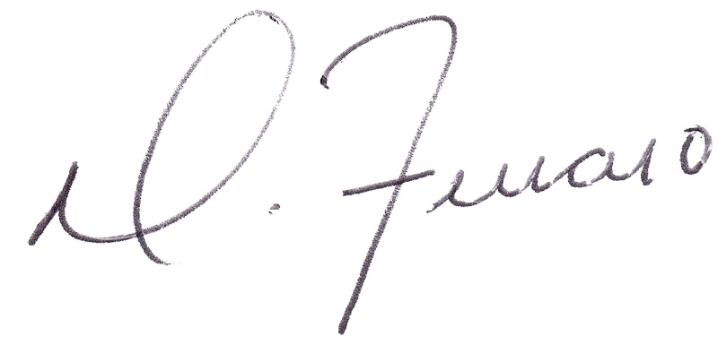
Disclosing Party:  Signature:  Print Name: Dominick J. Ferraro  Title: Managing Partner  Date: April 25, 2025 | Receiving Party:  Signature:  Print Name: Wesley Jones  Title: Owner  Date: April 25, 2025

