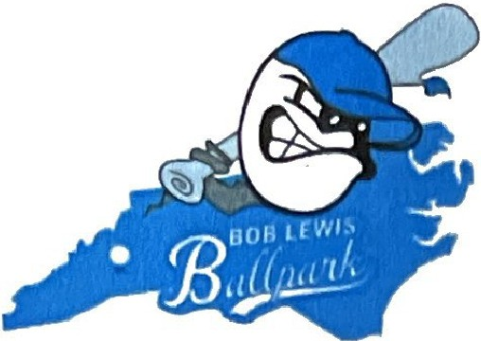
Enka Youth Sports Organization Bob Lewis Ballpark

2025 Tournament Field Rental Agreement

This Agreement (the "Agreement") is made as of Sunday, April 13, 2025, by and between the Enka Youth Sports Organization Inc. ("Owner'') and Perfect Game SEC, LLC ("Tournament Provider").

Whereas the Tournament Provider desires to temporarily rent, occupy, and make use of the Owner's venue, Bob Lewis Ballpark, located at 164 Jacob Holm Way, Asheville, NC, 28715, and

Whereas, the Owner agrees to such rental, occupation, and use in consideration of certain payments and covenants herein enumerated.

Both parties will plan, organize and manage the following events during the term of this Agreement.

Tournament Provider's 2025 Awarded Event Dates & Fees
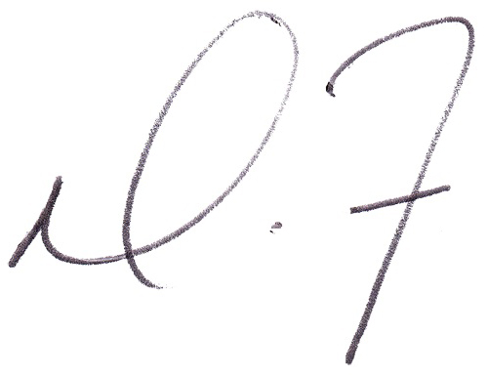
Date (s) | Tournament Name | Fees
March 22-23, 2025 | Baseball Tournament (2 Day) | $7,000
April 11, 2025 | Baseball Tournament {2 Days) | $750
April 12-13, 2025 | Baseball Tournament (1 Days) | $3,500
April 25, 2025 | Baseball Tournament {2 Day) | $750
April 26-27, 2025 | Baseball Tournament (2 Days) | $7,000
May 9, 2025 | Baseball Tournament {2 Days) | $750
May 10, 2025 | Baseball Tournament (2 Days) | $3,500
May 24-25, 2025 | Baseball Tournament (2 Days) | $7,000
June 20, 2025 | Baseball Tournament {2 Days) | $750
June 21-22, 2025 | Baseball Tournament (2 Days) | $7,000
July 5-6, 2025 | Baseball Tournament (2 Day) | $7,000
August 30-31, 2025 | Baseball Tournament {2 Days) | $7,000
September 5, 2025 | Baseball Tournament (1 Days) | $750
September 6-7, 2025 | Baseball Tournament {2 Day) | $7,000
September 27-28, 2025 | Baseball Tournament (2 Days) | $7,000
October 4-5, 2025 | Baseball Tournament {2 Days) | $7,000
October 17, 2025 | Baseball Tournament (2 Days) | $750
October 18-19, 2025 | Baseball Tournament (2 Days) | $7,000
November 1-2, 2025 | Baseball Tournament {2 Days) | $7,000

______ ______ Please initial here to confirm the dates above are correct.

Both parties agree to the following terms and conditions:
- Base Rental Fee & Contract Completion
Tournament Provider agrees to provide a Tournament Event on the dates indicated above at a rate of $7,000 per weekend (2 days) and for one day tournaments, the rates are $3,500. In addition to the base rental fee the tournament provider will provide the owner with a $1 per ticket fee at the conclusion of the event. The total value of the contract for the dates indicated above is $88,500.

Initial ________ ________
To hold these awarded dates, the signed contract must be received no later than August 14, 2025, along with a non-refundable deposit of $1,000, which will be applied toward payment of tournament fees for the final dates of November 8 - 9, 2025.

Rental Payment Policies
Tournament Provider agrees to pay the tournament fees in full, for each awarded date or set of dates as indicated in the table above, upon arrival to Bob Lewis Ballpark.

All tournament fees must be paid in full within two days of the conclusion of each tournament. If tournament balance is not paid in full prior to tournament conclusion, a 5% late fee will be added.

Tournament fees may be paid via check payable to Enka Youth Sports Organization Inc. and mailed to 1091 Hendersonville Road, Asheville, NC 28803 or delivered to Gary McDonald at Bob Lewis Ballpark.

- Certificate of Insurance (COI)
A Certificate of Insurance is required, listing the following as additional insured up to $2,000,000:

Damages
Enka Youth Sports Organization 1091Hendersonville Road Asheville, NC 28803
Bob Lewis Ballpark 164 Jacob Holm Way Asheville, NC 28715

The Tournament Provider will be liable for any physical damages, legal actions, and/or loss of reputation or business opportunities that Owner may incur as a consequence of the actions of Tournament Provider or any of Tournament Provider's guests while Tournament Provider is in control of the venue, and shall indemnify and hold harmless the Owner and it's staff against any and all legal actions which may arise from Tournament Provider's use of the venue.

Turf Protection: The Tournament Provider will be charged a fee of $300 per game for any team that is caught with sunflower seeds or chewing gum on Bob Lewis Ballpark Baseball fields. These items are known to cause significant damage to turf and are, therefore, strictly prohibited. Only turf shoes or molded cleats may be worn on the ballfields. It is the responsibility of the Tournament Provider to communicate these and any other stated policies to all participating teams prior to their arrival at the Bob Lewis Ballpark.

- Event Cancellation
In the event a tournament that has been awarded is canceled by the Tournament Provider, the Tournament Provider will forfeit all deposits paid. In the event a tournament is canceled by Bob Lewis Ballpark due to unforeseen conditions or acts of God, arrangements will be made to reschedule the event in the 2025 calendar year or the following year. If the event cannot be rescheduled, Bob Lewis Ballpark will refund any deposits paid by the Tournament Provider for the specific canceled event.

Responsibility Overview
  - For each event, Bob Lewis Ballpark (Owner) will perform the following services:
    - Field Maintenance. Bob Lewis Ballpark will ensure that fields are ready to host tournament games. This includes turf repairs, base alignment and cleaning, preparation and alignment of portable pitching mounds, and dugout cleaning.
    - Overall Facility and Restroom Maintenance. Bob Lewis Ballpark will coordinate overall facility maintenance, including trash removal, as well as restroom maintenance.
Initial ________ ________

    - Lighting. Bob Lewis Ballpark will provide sports lighting on the ballfields as needed.
    - Bob Lewis Ballpark staff will make the decision when it is appropriate to turn on the lights in consultation with the tournament director.
    - Security. Bob Lewis Ballpark will determine security support needed on tournament days. In the event it is determined that additional security is needed, this expense will be directly covered by the Tournament Provider. Bob Lewis Ballpark will work with the Buncombe County Sheriffs Department to determine security needs and with the Enka Fire Department in case of emergency medical support needs.

  - The Tournament Provider will be responsible for:
    - Scheduling. Tournament Provider will create an Official Schedule for each event and will publish the final schedule to the participating teams and Bob Lewis Ballpark prior to each event.
    - Marketing and Organization. Tournament Provider will perform all pre-planning services necessary to ensure that the event is appropriately promoted and organized. These services will include marketing, game scheduling, determining rules and policies, and logistical planning.
    - Registration and Management. Tournament Provider will secure and register all teams. Tournament Provider will perform on-site management regarding all tournament activities including check in, dispute resolution, and presiding over the championship awards presentation for each age division.
    - Event Staff and Umpires. Tournament Provider will hire event staff and umpires for each event and will accept recommendations from Bob Lewis Ballpark.
    - Equipment. Materials. Supplies and Awards. Tournament Provider will furnish all necessary supplies to execute each event, including game balls, bracket boards, first aid kits, etc.
    - Gate Staff. Tournament Provider will provide staff to collect gate monies.
    - Sales Tax. Tournament Provider is responsible for reporting and payment of any sales taxes due on revenue received through gate fees or other ancillary services, if applicable.
    - Policies. Tournament Provider agrees to follow all stated current and future policies and convey associated rules and regulations of Bob Lewis Ballpark to all Tournament teams, coaches, players, parents/family members and spectators. Policies include, but are not limited to, Visitor and General Park Rules; Prohibited Items and Substances; Team, Player and Astroturf Rules; as well as the latest Social Distancing, visitor and team policies as related to the COVID-19 pandemic.

- Waiver Forms
Tournament Provider agrees to include 'indemnification and hold harmless' language in their participant waiver forms releasing Bob Lewis Ballpark and Enka Youth Sports Organization Inc. from liability and agrees to assure that Tournament coaches (or their designates) distribute, collect signatures and manage Bob Lewis Ballpark liability waiver forms for all team members and coaches participating in tournaments at Bob Lewis Ballpark.

- Confidentiality
All information disclosed by one party to any other party under this Agreement will be considered confidential. Such a disclosure shall not operate in any way as a transfer of any rights to such information. Each party shall treat such information received from any other party as confidential and not disclose such information to any outside party except as necessary to perform the duties under this Agreement. No party may use the other party's confidential information for any purpose whatsoever, except as necessary to perform its obligations under this Agreement. Confidential information shall not include information that is generally known or publicly available or that is rightfully obtained by the other party independent of the disclosing party's disclosure of such information. This Section shall survive the expiration or termination of this Agreement.
Initial ________ ________
- National and Regional Sponsors and Vendors
In the event the Tournament Provider has a sponsor or vendor that wishes to participate in a tournament, this would be permissible only with the express written permission of Bob Lewis Ballpark. Bob Lewis Ballpark reserves the right to refuse any vendor or sponsor they believe would have an indirect conflict with a park sponsor or vendor or would negatively impact Bob Lewis Ballpark.

Non-Interference
Each party agrees not to solicit for employment any of the other party's employees or staff members for the term of this Agreement and for a period of one year thereafter. In addition, Tournament Provider agrees not to engage in deliberate speech or other conduct that prevents or disturbs Owner in the performance of its usual business activities or in the conduct of its business or contractual relations. This includes, but is not limited to, actively soliciting teams away from other contracted Tournament Promoters' events at Bob Lewis Ballpark. This Section shall survive the expiration or termination of this Agreement.

Independent Contractors
The parties are independent contractors of each other, and neither party has any responsibility for the wages and/or salaries of the other party's employees.

Entire Agreement
No other prior agreement between the parties exists and this Agreement as expressed herein constitutes the entire agreement between the parties.

Counterparts
This Agreement may be executed in counterparts and delivered via electronic transmission.

1
Any disputes arising under this contract shall be adjudicated in the Owner's local jurisdiction and subject to the
laws governing the State of North Carolina, County of Buncombe.

In witness of their understanding of, and agreement to, the terms and conditions herein contained, the parties affix their signatures below.

User Group's Signature & Date  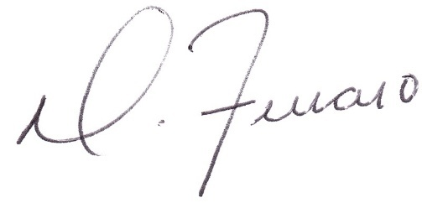 | Owner's Signature & Date
Printed Name  Perfect Game SEC, LLC | Printed Name  Gary McDonald
Organization Name  Perfect Game SEC, LLC | Organization Name  Enka Youth Sports Organization Inc.
Address  2607 Woodruff Road, Suite E227 | Address  1091Hendersonville Road
City, State, Zip Code  Simpsonville, South Carolina 29681 | City, State, Zip Code  Asheville, NC 28803

