Exclusive Two-Year Facility Usage and Partnership Agreement

Agreement between:

Perfect Game SEC, LLC. and North Wake Baseball at The Factory Baseball Complex

Effective Date: August 13, 2025

Prepared by: Perfect Game SEC, LLC

Exclusive Two-Year Facility Usage and Partnership Agreement

This Agreement is entered into on this 13th day of August, 2025 (the "Effective Date"), by and between Perfect Game SEC, LLC, with a principal place of business at 2607 Woodruff Road, Suite E227, Simpsonville, South Carolina 29681 , (hereinafter referred to as "PGSEC"), and North Wake Baseball at The Factory Baseball Complex, with a principal place of business at 1845 Grandmark Street, Wake Forest, NC 27587, (hereinafter referred to as "NWCBA").

WHEREAS, NWCBA desires to grant PGSEC exclusive use of The Factory Baseball Complex for a defined term;

WHEREAS, PGSEC and NWCBA agree to the terms and conditions set forth herein;

NOW, THEREFORE, in consideration of the mutual covenants and agreements contained herein, the Parties agree as follows:

- Term of Agreement

This Agreement shall commence on January 1, 2026 and shall continue for a period of two (2) years, concluding on December 31, 2027, unless terminated earlier in accordance with the provisions of Section 7 of this Agreement.

2. Exclusive Usage and Scheduling

2.1 Exclusive Weekends. PGSEC shall be granted the exclusive right to use the facilities for a total of thirty-two (32) weekends per year during the Term of this Agreement. A "weekend" shall be defined as the period from Friday at 5:00 PM to Sunday at 9:00 PM. PGSEC shall provide NWCBA with a detailed schedule of its exclusive weekends no later than Number days prior to the start of each calendar year of this Agreement.

2.2 Unused Weekends. PGSEC shall notify NWCBA in writing at least Seven (7) days in advance if an exclusive weekend will not be utilized. Any exclusive weekends that are not utilized by PGSEC may be allocated for use by travel team or middle school team practices, as determined by NWCBA. This usage is strictly prohibited for any perceived competitors, and for any and all TopGun and USSSA events.

3. Financial Terms

3.1 Daily Rate. PGSEC agrees to pay NWCBA a daily rate of two thousand three hundred dollars ($2,300) for each day of the exclusive usage period.

3.2 Invoicing and Payment. An itemized invoice shall be submitted annually by NWCBA to PGSEC. Monthly payments, as specified in the invoice, are due and payable via ACH.

3.3 Maintenance Fees. The existing maintenance fee of $600 per day will remain fixed for the duration of this agreement, applicable while the facility is in use by PGSEC.

3.4 Team Discount. PGSEC will maintain its existing team discount of twenty-five percent (25%), which will be applied to all applicable tournament registration fees.

4. Capital Contribution

NWCBA acknowledges and confirms its receipt of an initial capital contribution of $40,000 from PGSEC. The parties agree that no bid process was necessary for this contribution, and the related work has already commenced.

5. Operational Responsibilities

5.1 PGSEC's Responsibilities. PGSEC shall be responsible for the cost of its own turface quick dry and field marking chalk for all usage of the facilities.

5.2 NWCBA's Responsibilities. NWCBA shall be responsible for general facility maintenance, including but not limited to, providing access to facilities, and ensuring the fields are in a playable condition.

6. Insurance and Indemnification

6.1 Insurance. Each party shall maintain adequate general liability insurance coverage with limits of at least $2,000,000 per occurrence. Each party shall provide a certificate of insurance to the other upon request.

6.2 Indemnification. PGSEC & NWBCA agrees to indemnify and hold harmless the other party, its officers, employees, and agents, from and against any and all claims, damages, losses, and expenses arising from the indemnifying party's negligence or willful misconduct in connection with this Agreement.

7. Termination

This Agreement may be terminated under the following conditions:

(a) Mutual Agreement. This agreement may be modified, amended or teminated only by the mutual written consent of both parties.
(b) Breach. If either NWCBA or PGSEC reaches a material term of this Agreement and fails to cure such breach within thirty (30) days of receiving written notice from the non-breaching party.
(c) Force Majeure. In the event of a Force Majeure event as defined in Section 8.

8. Force Majeure

Neither Party shall be liable for any failure or delay in performing its obligations under this Agreement if such failure or delay is due to a Force Majeure event, including but not limited to acts of God, war, terrorism, pandemics, or natural disasters.

9. Dispute Resolution

Any dispute arising out of or relating to this Agreement shall first be submitted to good-faith negotiation between the parties. If negotiation fails, the parties agree to engage in mediation with a mutually agreed-upon third-party mediator.

10. General Provisions

10.1 Governing Law. This Agreement shall be governed by and construed in accordance with the laws of the State of North Carolina.

10.2 Entire Agreement. This Agreement constitutes the entire agreement between the Parties with respect to the subject matter hereof and supersedes all prior agreements, understandings, and negotiations, whether oral or written.

10.3 Notices. All notices required under this Agreement shall be in writing and delivered to the addresses set forth at the beginning of this Agreement.

10.4 Amendments. This Agreement may only be amended by a written instrument signed by both parties.

IN WITNESS WHEREOF, the Parties have executed this Agreement as of the Effective Date.

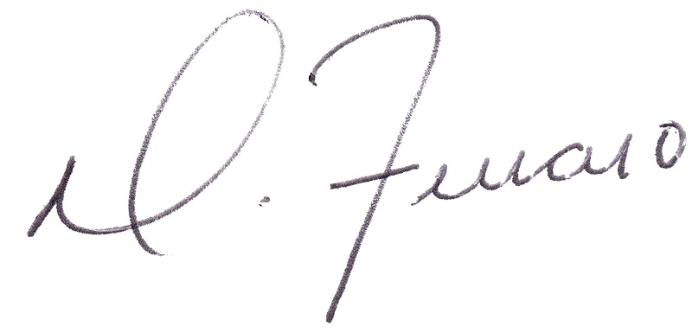
Perfect Game SEC, LLC  Signature:  Printed Name: Domnick J. Ferraro  Title: Manging Partner | NWCBA at The Factory Baseball Complex  Signature:  Printed Name:  Title:

